Java Multithreading: Synchronization, Locks, Executors, Deadlock, CountdownLatch & CompletableFuture

- https://www.youtube.com/watch?v=4aYvLz4E1Ts&t=2403s

CPU :
The CPU, often referred to as the brain of the computer, is responsible for executing instructions from programs. It performs basic arithmetic, logic, control, and input/output operations specified by the instructions.

Ex: A modern CPU like the Intel Core i7 or AMD Ryzen7

CORE :
A core is an individual processing unit within a CPU. Modern CPUs can have multiple cores, allowing them to perform multiple tasks simultaneously.

Ex: A quad-core processor has four cores, allowing it to perform four tasks simultaneously. For instance, one core could handle your web browser, another your music player, another a download manager, and another a background system update.

PROGRAM :
A program is a set of instructions written in a programming language that tells the computer how to perform a specific task.

Ex: Microsoft Word is a program that allows users to create and edit documents.

PROCESS :
A process is an instance of a program that is being executed. When a program runs, the operating system creates a process to manage its execution.

Ex: When we open Microsoft Word, it becomes process in the operating system.

THREAD :
A thread is the smallest unit of execution within a process. A process can have multiple threads, which share the same resources but can run independently.

Ex: A web browser like Google Chrome might use multiple threads for different tabs, with each tab running as a separate thread.

MULTITASKING :
Multitasking allows an operating system to run multiple processes simultaneously. On single-core CPUs, this is done through time-sharing, rapidly switching between tasks. On multi-core CPUs, true parallel execution occurs, with tasks distributed across cores, The OS scheduler balances the load, ensuring efficient and responsive system performance.

Ex: We are browsing the internet while listening to music and downloading a file.

Multitasking utilizes the capabilities of a CPU and its cores. When an operating system performs multitasking, it can assign different tasks to different cores. This is more efficient than assigning all tasks to a single core.

MULTITHREADING :
Multithreading refers to the ability to execute multiple threads within a single process
concurrently.

Ex: A web browser can use multithreading by having separate threads for rendering the page, running JavaScript, and managing user inputs. This makes the browser more
responsive and efficient.

Multithreading enhances the efficiency of multitasking by breaking down individual tasks into smaller sub-tasks or threads. These threads can be processed simultaneously, making better use of the CPU's capabilities.

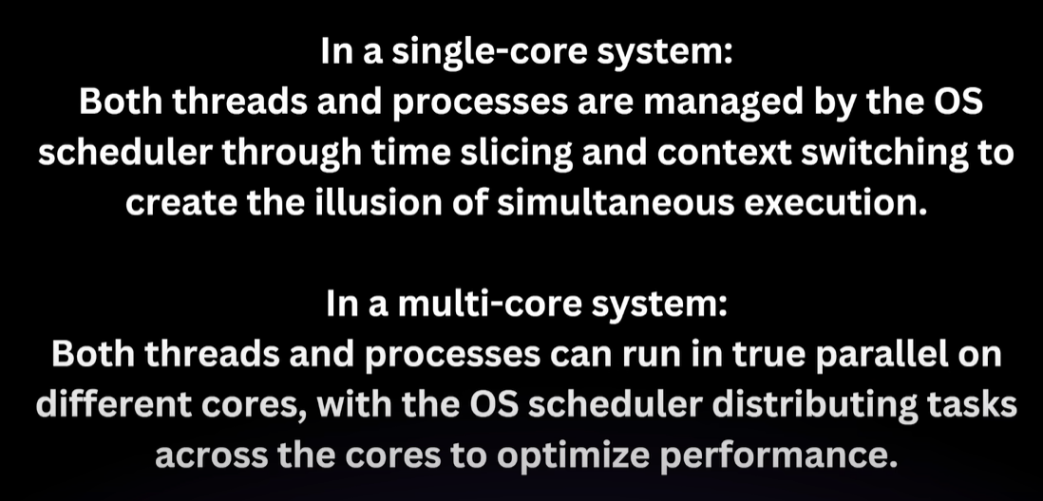

TIME SLICING :
Definition: Time slicing divides CPU time into small intervals called time slices or quanta.

Function: The OS scheduler allocates these time slices to different processes and threads, ensuring each gets a fair share of CPU time.

Purpose: This prevents any single process or thread from monopolizing the CPU, improving responsiveness and enabling concurrent execution.

CONTEXT SWITCHING :
Definition: Context switching is the process of saving the state of a currently running process or thread and loading the state of the next one to be executed.

Function: When a process or thread's time slice expires, the OS scheduler performs a context switch to move the CPU's focus to another process or thread.

Purpose: This allows multiple processes and threads to share the CPU, giving the appearance of simultaneous execution on a single core CPU or improving parallelism on multi-core CPUs.

MULTITASKING VS MULTITHREADING :
Multitasking can be achieved through multithreading where each task is divided into threads that are managed concurrently.

While multitasking typically refers to the running of multiple applications, multithreading is more granular dealing with multiple threads within the same application or process.

Multitasking operates at the level of processes, which are the operating system’s primary units of execution. Multithreading operates at the level of threads, which are
smaller units within a process.

Multitasking involves managing resources between completely separate programs, which may have independent memory spaces and system resources. Multithreading involves managing resources within a single program, where threads share the same memory and resources.

Multitasking allows us to run multiple applications simultaneously, improving productivity and system utilization. Multithreading allows a single application to perform multiple tasks at the same time, improving application performance and responsiveness.

The office manager (operating system) assigns different employees (processes) to work on different projects (applications) simultaneously. Each employee works on a
different project independently.

Within a single project (application), a team (process) of employees (threads) works on different parts of project at the same time collaborating and sharing resources.

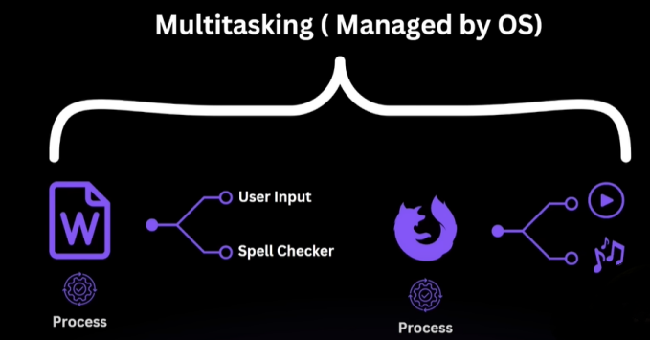

JAVA MULTITHREADING :
In Java, multithreading is the concurrent execution of two or more threads to maximize the utilization of the CPU. Java's multithreading capabilities are part of the java.lang package, making it easy to implement concurrent execution.

In a single-core environment, Java's multithreading is managed by the JVM and the OS, which switch between threads to give the illusion of concurrency.The threads share the single core, and time-slicing is used to manage thread execution.

In a multi-core environment, Java's multithreading can take full advantage of the available cores.The JVM can distribute threads across multiple cores allowing true parallel execution of threads.

A thread is a lightweight process, the smallest unit of processing. Java supports multithreading through its java.lang.Thread class and the java.lang.Runnable interface.

When a Java program starts, one thread begins running immediately, which is called the main thread. This thread is responsible for executing the main method of a program.

To create a new thread in Java, you can either extend theThread class or implement the Runnable interface.

In both cases, the run method contains the code that will be executed in the new thread.

Ex: com/swapnil/multithreading/ex1

THREAD LIFECYCLE :
The lifecycle of a thread in Java consists of several states, which a thread can move through during its execution.

New: A thread is in this state when it is created but not yet started.

Runnable: After the start method is called, the thread becomes runnable. It's ready to run and is waiting for CPU time.

Running: The thread is in this state when it is executing.

Blocked/Waiting: A thread is in this state when it is waiting for a resource or for another thread to perform an action.

Terminated: A thread is in this state when it has finished executing.

But in java we have following State:

- NEW: When Thread is created.

- RUNNABLE: After the start method is called, the thread becomes runnable.[In java there is no RUNNING state as mentioned in above theory, when thread is executing its also considered as RUNNABLE state]

- TIMED_WAITING: Thread state for a waiting thread with a specified waiting time.

- TERMINATED: A thread is in this state when it has finished executing.

Ex: com/swapnil/multithreading/ex2 [THREAD START, RUN, SLEEP, JOIN]

THREAD MEHTODS:

Ex: com/swapnil/multithreading/ex3 [THREAD NAMING, PRIORITY]

Ex: com/swapnil/multithreading/ex4 [THREAD INTERRUPT]

Ex: com/swapnil/multithreading/ex5 [THREAD YIELD]

Ex: com/swapnil/multithreading/ex6 [THREAD DEAMON]

SYNCHRONIZATION:

The synchronized keyword is used on method or bock of code which means single thread can perform operation at time.

Part of code where shared resources accessed or modified is called critical section.

A race condition occurs when two or more threads access shared data and try to change it at the same time, and the final result depends on the order of execution — which is unpredictable.

Ex: com/swapnil/multithreading/ex7

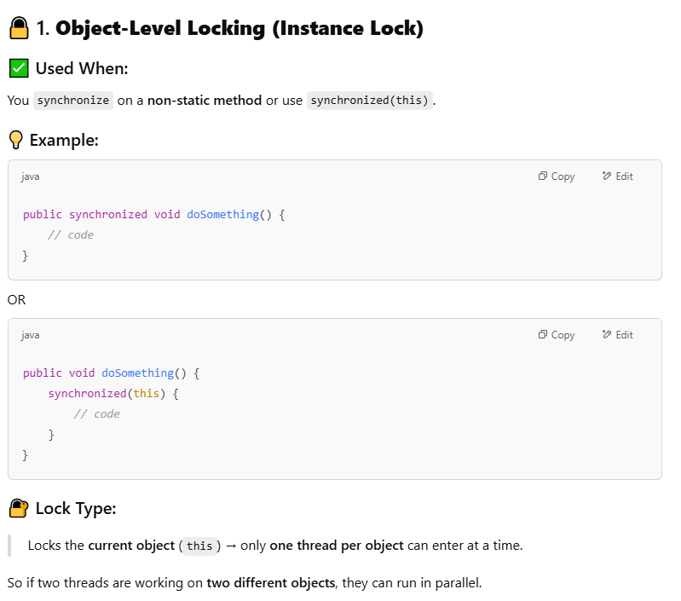

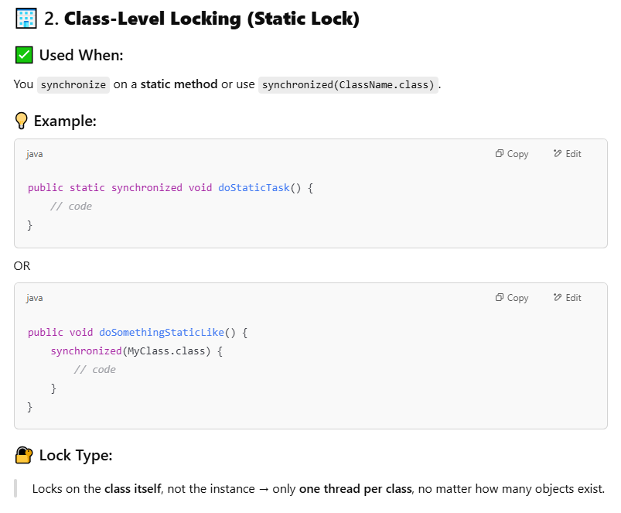
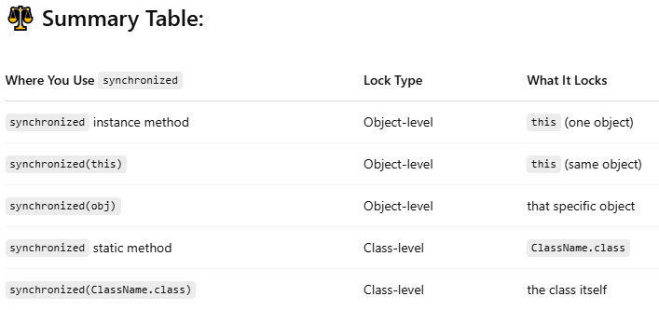

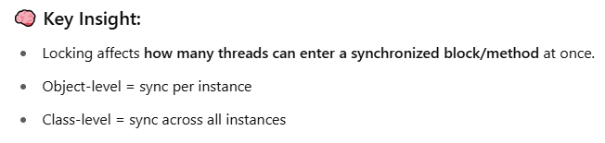

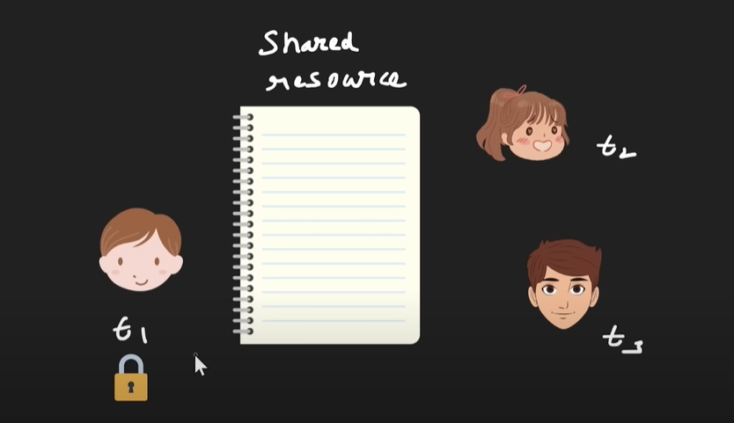

As we used synchronized on shared resources, thread1 will perform operation and acquire lock so nobody can enter(thread2, thread3)

LOCKING:

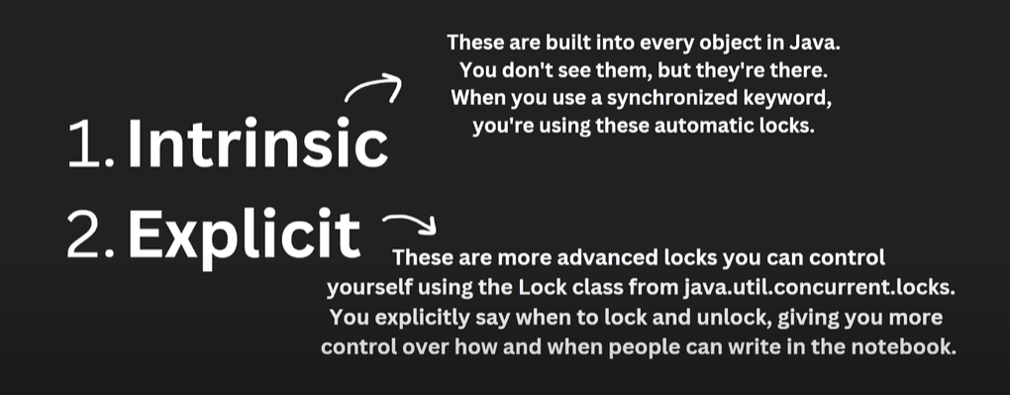

Intrinsic lock are automatic so we don’t have control like thread2 will execute only after thread1 release lock no matter how much time thread1 can take, but in Explicit we can control as this are manual lock.

Ex:

private final Lock lock = new ReentrantLock();

Lock is interface present in java.util.concurrent.locks.Lock

ReentrantLock provide implementation of Lock interface

Methods:

lock() : current thread will wait for existing thread to release lock.[just like synchronization]

tryLock(): will check if lock is available at that moment if not it will return false.

tryLock(1000, TimeUnit.MILLISECONDS) : will wait for provided time to acquire lock, if not able acquire in provided time it will return false.

Note: tryLock() will not throw InterruptedException but tryLock(1000, TimeUnit.MILLISECONDS) can because it allows thread to wait so there is chance of interruption, just like Thread.sleep().

If we use lock.tryLock() then always release it, lock.unlock(). It will not relased automatically as its manual lock.

Ex: com/swapnil/multithreading/ex8

ReentrantLock maintain count internally how many times lock.lock() is executed same time we need to lock.unlock() to release lock for next thread.

Ex: com/swapnil/multithreading/ex9

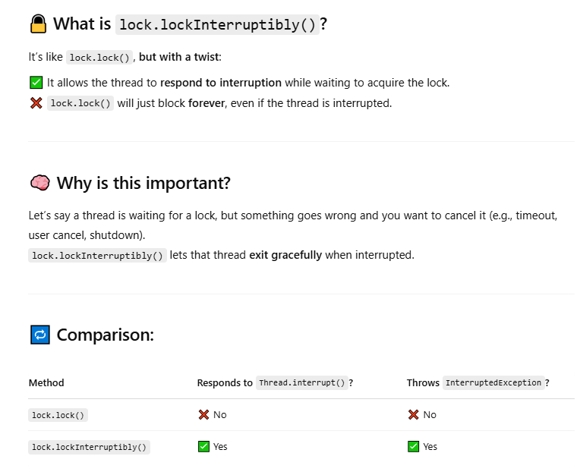
Ex: com/swapnil/multithreading/ex10

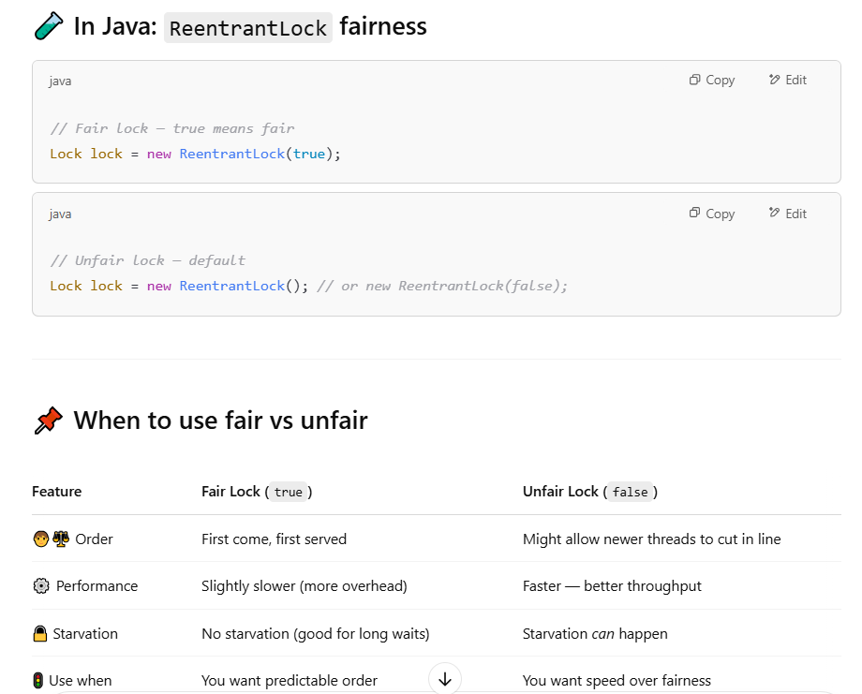

Ex: com/swapnil/multithreading/ex11

DISADVANTAGES OF SYNCHRONIZATION:

- No Fairness
- Blocking
- No Interruptibility
- No Read/Write Locking(In manual locking we can create separate lock but not in synchronization)

Ex: com/swapnil/multithreading/ex12

DEADLOCK:


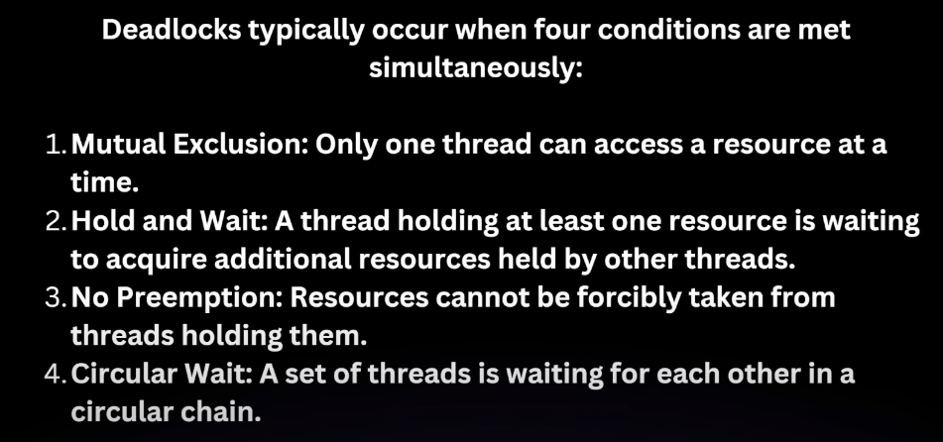

Ex: com/swapnil/multithreading/ex13

THREAD COMMUNICATION:




wait(), notify(), notifyAll() are the methods used for thread communication and always used in synchronized context.

Ex: Consider producer and consumer, so without proper communication consumer always check whether producer produced data or not, leading to wastage of CPU resources. Its better when producer will notify to consumer when it produces data .

wait() : will release lock for current thread and wait for notify() of other threads.

notify() : wakes up single thread that is waiting.

notifyAll() : wakes up all thread that is waiting.

Ex: com/swapnil/multithreading/ex13

THREAD SAFETY:
An object or block of code is called thread safe it guaranties it will not generate unpredictable result, race condition and data corruption.

Ex: String VS StringBuilder VS StringBuffer

